

**School of Advanced Technology**

**Final Year Project**

**Project Specification Report**

Project Title: Virtual Reality Questionnaire Toolkit: Examining Interaction Techniques for Doing Questionnaires in VR

Student Name: Xingbo Wei

Student ID: 1824150

Project field: Human-Computer Interaction

Supervisor: Yue Li

1. **Project Introduction**

The notable rise of a new generation of virtual reality (VR) systems in recent years opened up new methods and interventions for researchers across different areas. It is vital for VR research and development to understand users’ subjective feedback, which is usually assessed through questionnaires after leaving a VR scene. Recent research has found that completing questionnaires directly in VR can help mitigate the break in presence (BIP). In this final year project, the student will develop a Virtual Reality Questionnaire Toolkit (VRQTK) and examine the interaction techniques for doing questionnaires in VR.

As the development of the Virtual Reality (VR) technology, head-mounted displays (HMD) are becoming popular. VR has since been applied to many areas such as computer graphics, gaming, or education [1], [2] and during 2020 fourth quarter alone there were over one million Quest 2 units sold worldwide [3]. Questionnaire is one way to evaluate the application which allows product owner or developer to understand its upsides and downsides like measuring presence or immersion from the questionnaire result.

Despite paper questionnaire is a way to evaluate most current application or production. However, traditional appraisal methods have inadequacy. Putze Susanne et al. describes the ﻿switching between VR and physical reality leads to a break in presence [3] ﻿that might alter the outcomes [4]. Embedding question items in the VE offers a way to stay closer to the context of an ongoing experience[5], Putze Susanne et al. [3] ﻿show evidence that in virtual reality questionnaire (VRQ) are less invasive than out VRQ.

In this project I propose Virtual Reality Questionnaire Toolkit (VRQTK), a tool enable questionnaire to be the part of the VR experience and interact with the user and virtual environment (VE) and exploring a suitable VRQTK in VE.

1. **Related Work**

Valentin et al. proposed one of the earliest approaches to measuring presence for VEs [3]. They investigated the effect of questionnaire simulation on the sense of presence within VEs. ﻿Some items, however, contained diversity questions, thus, had to be further refined. Dmitry et al [5]. based on previous work and theoretical, compare INVRQs and OUTVRQs and discuss the positive of INVRQ This indicates that the field may benefit from building awareness and providing guidelines. In order to improive the effectiveness of VRQ, I intend to test different questionnaire forms to determine the a suitable VRQTK to measuer different indicator.

1. **Methodology**

This project will first do a literature review on the research conducted on the area of VRQ and focus on design and experimental process. In this step, all the relevant VRQ method should be collected, for example, the slider block (as shown in Figure 1.) and rating scales (as shown in Figure 2.) are the sample questionnaire interface to collect the user data. Moreover, to make the project more convincing, we also gathered the ﻿EEG signal to measure the participant brain signal to decate user real interaction [6]. In the last step of the experiment, we will interview participants to prepare for subsequent qualitative analysis.

* 1. **Quantitative Methods**

﻿After the sample game, we measured presence in the VE using IPQ on a Likert scale with the subscales *general presence* (GP), *spatial presence* (SP), *involvement* (INV) and *experienced realism* (REAL). Furthermore, we asked the participants to rate the game and the perceived control over on a 10-ticks slider. Meanwhile, the Muse will decate your brain wave and reflect three region: *active*, *neutral* and *calm.* Compare the results of the questionnaire from lateral based on your brain wave data. Quantitative data was analyzed using IBM SPSS Statistics. Mean comparison was conducted using ANOVA. Post hoc differences between conditions were analyzed with Tukey tests. Responses to open questions were analyzed using content analysis methods.

**3.3 Qualitative Methods**

We will conduct the expert interview to determine which design elements can be applied to this toolkit. The the qualitative data will be analyzed by using NVIVO respectively. Moreover, since participatory design could quickly capture user’s requirements, not only for functionality but also for UI and interaction with visual results.

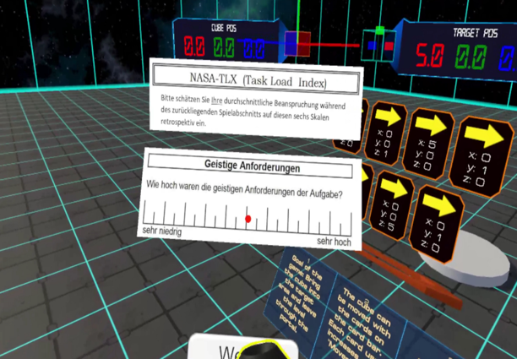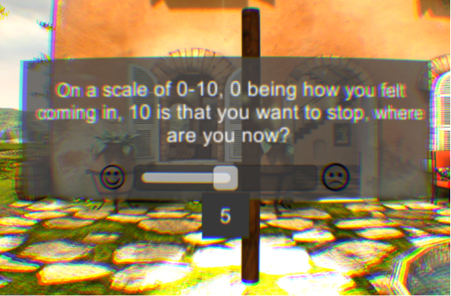

Figure 1. the scale of comfort level ranged from 0 to 10 [7]. Figure 2. six continuous rating scales [8].

1. **Project plan (Timeline)**

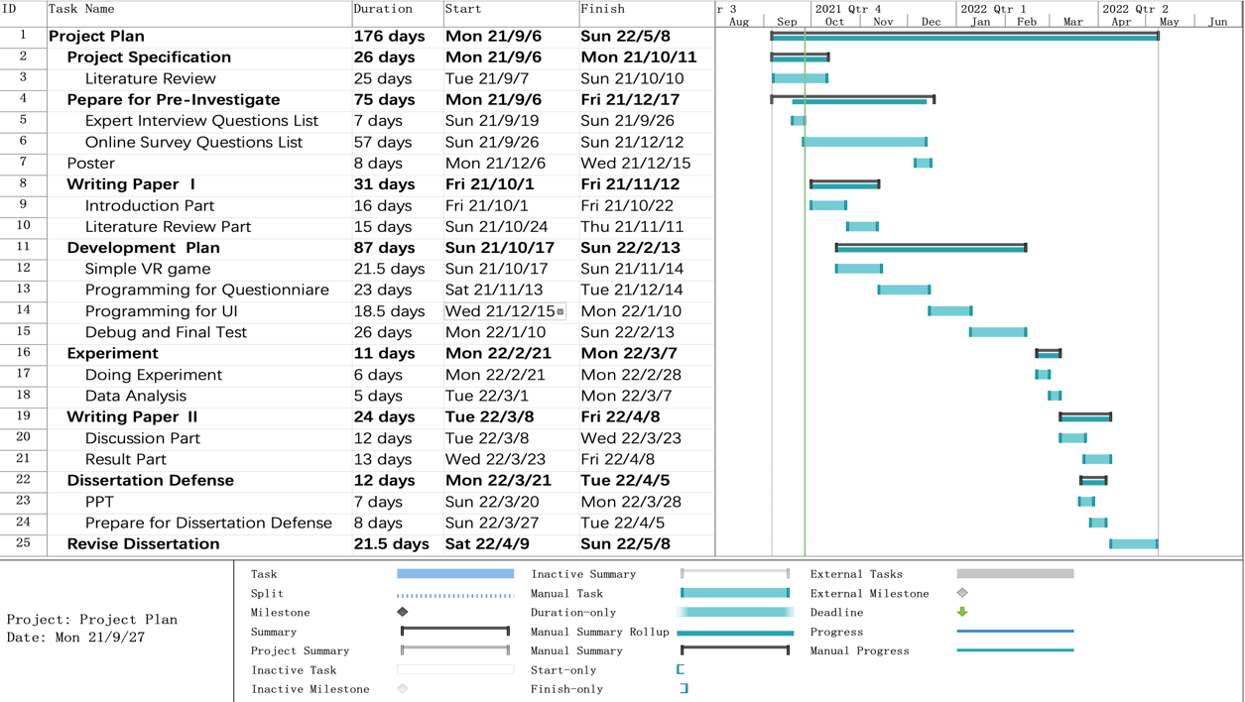The literature review, known the various of VRQ interaction way, an appropriate VRQTK will be end at this semter. At the beginning of next semester, the experiment is processing and the analysis will based on the experiment result. The project objective is expected to be achived before week 13 in the next semester.

1. **Project deliverables (Expected outcomes)**
2. A summarized report about designing a suitable questionnaire that helps mitigate break in presence in virtual reality.
3. A complete virtual reality questionnaire toolkit (VRQTK) which can be used in different virtual reality environments.

**Project Industrial Relevance:**

Currently, there is no toolkit for questionnaires in the Unity Asset Store. The purpose of this project is to develop a suitable questionnaire toolkit to reduce the pressure on developers, so that they only need to focus on the development itself.

**References:**

[1] J. Pirker, A. Dengel, M. Holly, and S. Safikhani, “Virtual Reality in Computer Science Education: A Systematic Review,” *Proc. ACM Symp. Virtual Real. Softw. Technol. VRST*, 2020, doi: 10.1145/3385956.3418947.

[2] X. Guo, X. Chen, X. Feng, and S. Zheng, “The Enlightenment of ‘aR / VR’ Technical University Course Education in Taiwan, China,” *ACM Int. Conf. Proceeding Ser.*, pp. 22–28, 2020, doi: 10.1145/3439133.3439146.

[3] S. Putze, D. Alexandrovsky, F. Putze, S. Höffner, J. D. Smeddinck, and R. Malaka, “Breaking the Experience: Effects of Questionnaires in VR User Studies,” *Conf. Hum. Factors Comput. Syst. - Proc.*, pp. 1–15, 2020, doi: 10.1145/3313831.3376144.

[4] V. Schwind, P. Knierim, N. Haas, and N. Henze, “Using presence questionnaires in virtual reality,” *Conf. Hum. Factors Comput. Syst. - Proc.*, pp. 1–12, 2019, doi: 10.1145/3290605.3300590.

[5] D. Alexandrovsky *et al.*, “Examining Design Choices of Questionnaires in VR User Studies,” *Conf. Hum. Factors Comput. Syst. - Proc.*, pp. 1–21, 2020, doi: 10.1145/3313831.3376260.

[6] R. M. Winters and S. Koziej, “An auditory interface for realtime brainwave similarity in dyads,” *ACM Int. Conf. Proceeding Ser.*, pp. 261–264, 2020, doi: 10.1145/3411109.3411147.

[7] A. S. Fernandes and S. K. Feiner, “Combating VR sickness through subtle dynamic field-of-view modification,” *2016 IEEE Symp. 3D User Interfaces, 3DUI 2016 - Proc.*, pp. 201–210, 2016, doi: 10.1109/3DUI.2016.7460053.

[8] S. Oberdörfer, D. Heidrich, and M. E. Latoschik, “Usability of gamified knowledge learning in VR and Desktop-3D,” *Conf. Hum. Factors Comput. Syst. - Proc.*, pp. 1–13, 2019, doi: 10.1145/3290605.3300405.

[9] Aslop. (2021, Sep. 8) *Oculus Quest 2 Headset Unit Sales Worldwide From 2020 To. 2021* [Online]. Available:

<https://www.statista.com/statistics/1249850/oculus-quest-2-units-sold-by-quarter/>

[10] Lyons. (2017, Dec. 3) *Rendering Text in WebVR* [Online]. Available:

https://developers.google.com/web/showcase/2017/within